LINUX PROGRAMMING: ASSIGNMENT-2
Submitted By : Urvija Kapila , 3C , Roll No: 11, ENG24CY0063

- What does the command pwd, whoami, and hostname display? (CO1)
Ans: pwd stands for Present Working Directory . It is used to display the full path of the directory that you are currently in.
Whoami is a command that helps us to know the name of the current logged in user.
Hostname is a command in Linus that tells the name of the computer (host) on the network.

- Write the command to create a directory named “project” inside the /home/student folder and keep three .txt file into it. Give output snapshot. (CO1)
Ans : The command used here will be “mkdir” .
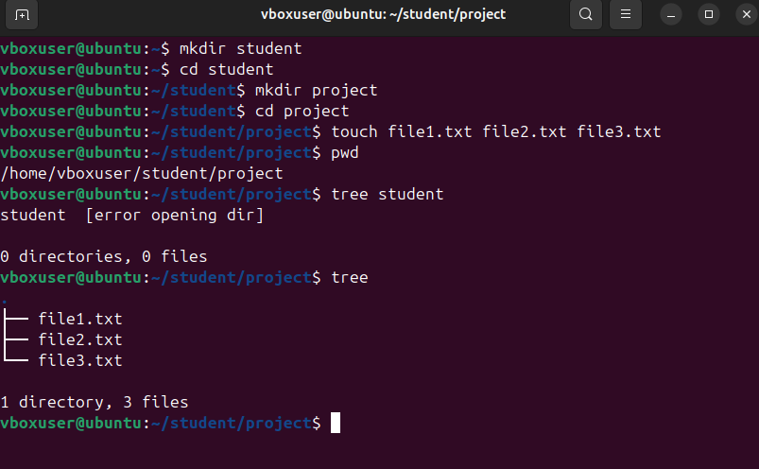

- Explain the difference between absolute path and relative path with proper examples. (CO2)
Ans: Absolute Path: The complete path starting from the root directory (/) to the desired file or folder. An absolute path always begins with /.It is not relative to the current working directory.
Example: /home/urvija/project/file1.txt
Here this path will always reference the same file regardless of your current location in the filesystem.

Relative Path : A path that is relative to the current working directory . A relative path does NOT begin with /. It is dependent on your current location in the filesystem.

Example: Let us say your current directory is /home/urvija:
cd project
# OR
./project/file1.txt
Here, project/file1.txt corresponds to a relative path to the same file file1.txt from the directory /home/urvija.

- What command will give you the already executed command traces in the terminal. Give output snapshot. (CO1)
Ans: The command used for this is “history” .
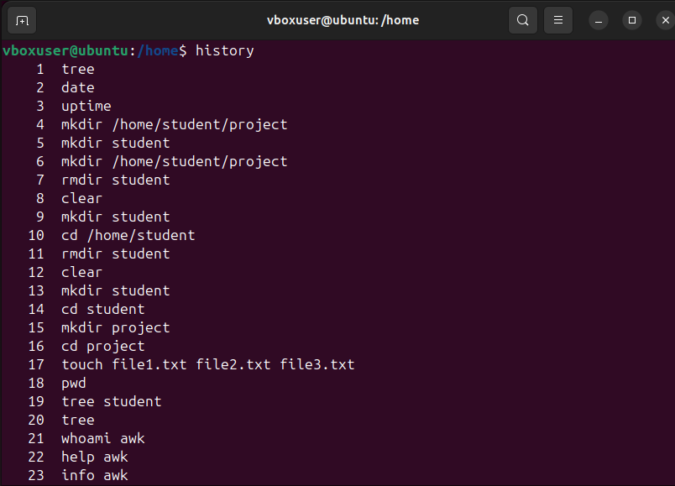

- Compare the working functionality of find and locate command. Which one is faster and why? (CO1)
Ans: The find and locate commands operate fundamentally differently, and the locate command is much faster. The find command does real-time searches based on the criteria specified, and produces live results, as files could be created or deleted within the directory you are investigating. The downside is that there is a lot of disk I/O with find, especially if the directory is large, which can be very slow.
Whereas, the locate command checks a prebuilt database file and directory which is typically updated once a day using a scheduled job like updatedb. Because locate is performing a simple query against a pre-indexed database rather than scanning the filesystem, it is much faster. The disadvantage is that the results may not be completely accurate because files that were created or deleted since the last update will not be reflected in the results. In conclusion, find can be very powerful and return real-time results accurately all times. Locate will provide very fast results and is acceptable when you do not require completely up to date data.
Locate command is faster for files because it is searching a file structure in a database as opposed to scanning the filesystem live.

- Which command is used to modify file permissions in Linux? Give an example. (CO1)
Ans: We use the command “chmod” to modify file permissions in Linux. It controls who can read a file, write to a file or execute a file. There are three types of permissions: Owner (user) - the user that owns the file , Group -the users that are in the same group as the file , Others - everyone else.

- A file has permissions -rw -r- -r- -. What does this mean? (CO1)
Ans: The given permissions show that the file is a regular file and not a directory.
r w - means that the owner can read & edit it.
r - - means that the group is allowed only to read the file
r - - means that others can only read and not execute the file.

- Explain the difference between chown and chgrp with an example. (CO1)
Ans: The command called "chown" in Linux is the command to change the ownership of a file or directory; it has the option to change the group as well. The command "chgrp" is to change the group of a file or directory and does not change the ownership. For example, if a file is owned by alice, and it belongs to the group staff, using chown would make urvija the owner (with the option to change the group as well), and using chgrp would only change the group to developers while still keeping alice as the owner. Therefore, chown changes the owner, and chgrp changes the group.

- A file needs to be accessible by multiple users but only writable by the owner. How will you set permissions? (CO1)
Ans : To make a file readable by multiple users but writable only by the owner, we can set the permissions by giving the command: chmod 644 filename
6 → Owner: read + write (rw-)
4 → Group: read only (r--)
4 → Others: read only (r--)
This will then change the permission string to: -rw-r--r—
This allows the owner to be the only person who can write the file, while the rest of the users are allowed to read the file.

- How do you check the manual page for any Linux commands? (CO1)
Ans: The manual page for any Linux command can be obtained by simply typing the “man” command in the terminal followed by the required command name. This opens a pager that displays all the official documentation related to the typed command . We can scroll through it to find the various flags it offers with their explanation and just press q to come back to the terminal.

